Discuss Minsky's Financial Instability Hypothesis about the nature and origin of financial crises in modern economics

In this paper I will explain Minsky’s Financial Instability Hypothesis (FIH) and extend it to include a model of ‘cash-in-the-market pricing’ developed by Allen & Gale (2007).

The Financial Instability Hypothesis models the economy such that exogenous shocks are not necessary to generate business cycles (Minsky, 1992). Instead, business cycles are endogenous. Minsky (2008) begins with a monetary theory of production, i.e., firms must acquire finance to produce goods; see Figure I.

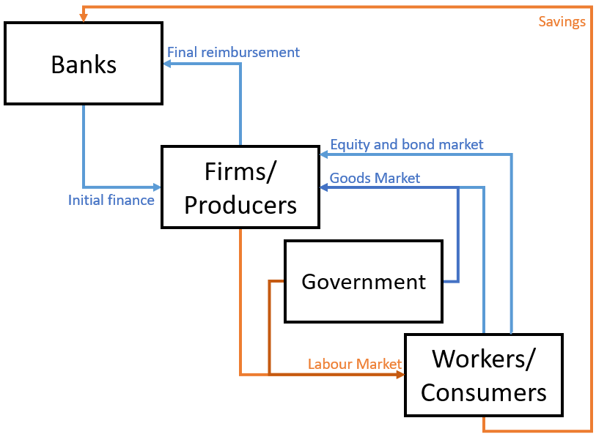

Figure – adapted from (Realfonzo, 2006, p. 107)

Arrows indicate monetary flows; flows which help firms repay debt commitments are in blue, flows which hinder them are in orange. Bear in mind:

1. Firms’ costs are labour and capital, but capital expenditure circulates amongst firms,
2. We assume banks do not spend their interest earnings,
3. Taxes paid to the government are not shown here.

For firms, the banks’ initial finance creates a definite final reimbursement obligation. However, firms do not necessarily know whether they will be able to fulfil this commitment: to reimburse banks, earnings by firms in the goods, equity and bond markets must be more than or equal to the quantity spent in the labour market (plus interest). Therefore, firms’ ability to honour debt commitments depends on consumer and the government behaviour. These factors are uncertain and banks therefore lend based on firms’ profit expectations; see Figure II.

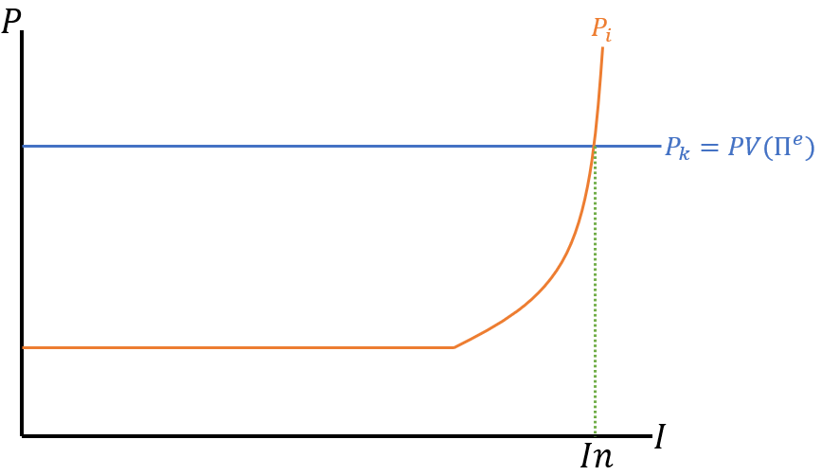

Figure – adapted from (De Antoni, 2006, p. 157)

Figure II models the demand and supply price of capital assets. The demand price $P_{k}$ is equal to the present value of future profit expectations $PV(Π^{e})$ from operations; if $P_{k}>PV\left(Π^{e}\right)$, investors make a loss, so $P_{k}=PV(Π^{e})$ the maximum price willing to be paid. The supply price $P_{i}$ is the marginal cost of asset production which eventually curves upward due to diminishing marginal productivity.

For simplicity, assume we are at the start of the monetary circuit. Firms cannot make investments $In$ as they have no access to funds and consumers have no earnings to buy equity or bonds; banks therefore provide all financing; see Figure III.

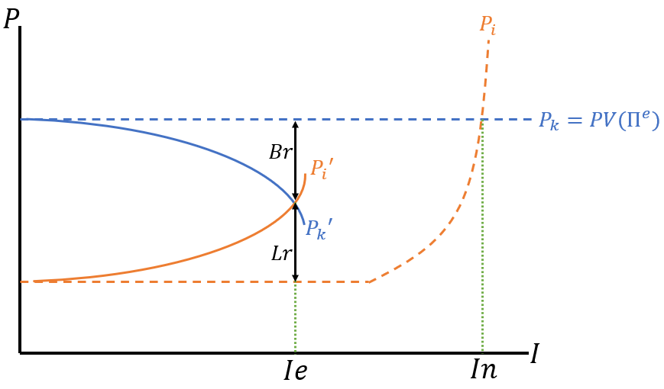

Figure – adapted from (De Antoni, 2006, p. 157)

In Figure III, borrower risk $Br$ and lender risk $Lr$ are priced into investment decisions. $Lr$ is expressed as an increased interest rate on loans pushing up the firms’ perceived asset cost $P_{i}→P_{i}'$, and $Br$ is the cash-flow margin desired by firms to accept risk (Minsky, 2008, pp. 213-4). $Br$ and $Lr$ increase with the size of the investment until they meet at an equilibrium level of investment $Ie$.

If firms experience an unexpected but seemingly permanent increase in profits (a boom), profit expectations and confidence in firms will shift the diagram to Figure IV (De Antoni, 2006, p. 160).

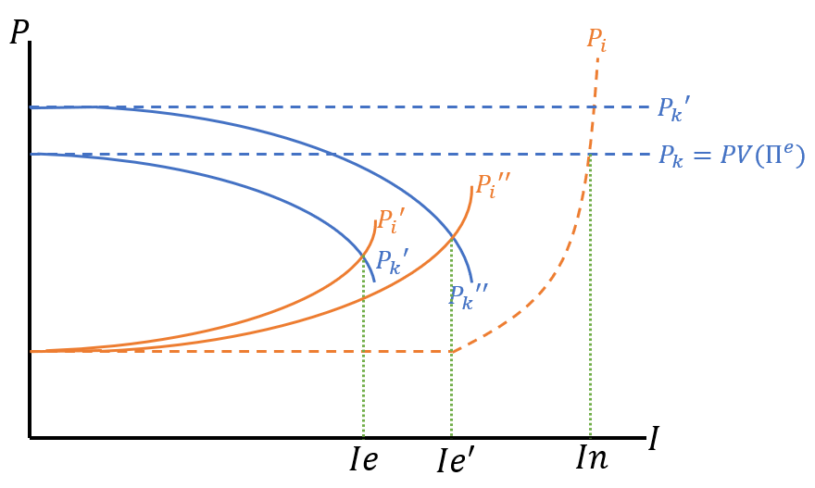

Figure - adapted from (De Antoni, 2006, p. 160)

For the sake of simplicity, we again ignore equity and bond markets. Increased profit expectations shift $P_{k}$ to $P_{k}'$ and increased confidence decreases $Br$ and $Lr$ for the same level of investment. These changes combine and $Ie$ increases to $Ie'$.

Minsky (2008, p. 230) posits that some firms and their bankers will speculate on these potential booms. Minsky (*ibid*) defines three categories:

1. Hedge,
2. Speculative,
3. Ultra-speculative or ‘Ponzi’.

These can be described with a novel diagram, see Figure V.

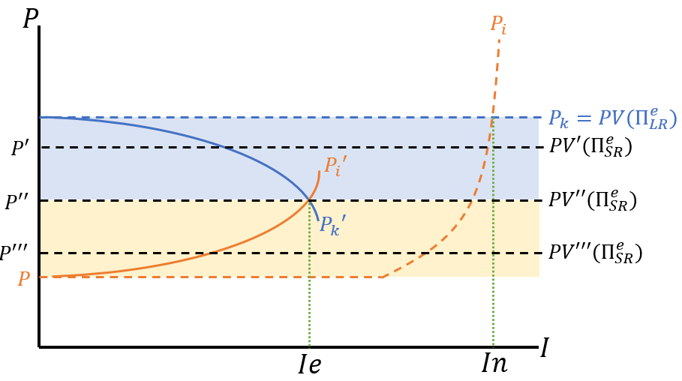

Figure – own illustration, adapted partly from (De Antoni, 2006)

Figure V delineates long-run and short-run profit expectations.

$$P^{''}=r=i+x$$

Where the market rate $r$ is equal to the risk-free rate $i$ plus a risk premium $x=Lr$. Minsky (*ibid*) defines hedge investors as agents who are not dependent on finance after the initial loan: they receive sufficient cashflow to repay interest and the principal: $PV^{'}\left(Π_{SR}^{e}\right)>r$. Speculative investors have $PV^{''}\left(Π_{SR}^{e}\right)=r$ and roll-over their debt until long-run expectations are realised; Ponzi investors have $PV^{'''}\left(Π_{SR}^{e}\right)<r$ and require new loans to stay solvent in the short-run.

Speculators exceeding profit expectations eventually leads to the endogenous accumulation of financial fragility. During the upswing, speculators prove to banks that their projected long-run expectations were valid. Meanwhile, hedgers will realise they did not fully utilise available leverage and are incentivised to do so. As a result, firms become increasingly reliant on the financial sector to roll-over debt or maintain a flow of credit.

When expectations are not met, due to either reduced government spending or increased consumer savings, there is a ‘Minsky moment’. Liquidity preference across the entire economy rises precipitously due to strong uncertainty, meaning that: consumers save more in banks, rather than via the equity and bond market; banks shift from illiquid loans to liquid investments such as treasuries; and firms demand financing to service their debt and meet their ballooning risk margin $Br$ (Dow, 2006, p. 41). Firms do not attain extra financing due to banks’ unwillingness to lend and must sell capital assets. This causes a spiral of debt-deflation, wherein asset prices collapse due to excess supply, requiring firms to sell more to meet their debt commitments.

Ultimately, not all commitments can be fulfilled and there will be a wave of bankruptcies, followed by a recovery period dominated by hedged investment until the cycle repeats. Some critics argue such a cyclical nature would require people to behave irrationally, never learning from mistakes; however, this is not a necessary assumption. As Skott (1996, p. 270) notes, knowledge from past mistakes does not help with present situations: past crises lead to changes in the institutional environment wherein novel innovations will render previously risky actions safe, and safe actions risky. Agents trying to extrapolate from past experiences will be “in the positions of generals using the strategies of a previous war.” (*ibid*).

**Expanding Minsky to account for liquidity uncertainty**

Allen & Gale (2007, p. 20) suggest two mechanisms which can crash asset prices: falling future returns, and unexpected liquidity shocks. Minsky is primarily concerned with the former, however Allen & Gale’s (2007) ‘cash-in-the-market pricing’ model shows that liquidity shocks can cause crashes to occur even when asset returns are certain. By extending Minsky’s FIH to include both mechanisms, it can better model financial crises.

Cash-in-the-market pricing occurs when there is a liquidity shortage and the asset price becomes equal to the ratio of available liquidity to the amount of the asset supplied. Allen & Gale (2007, p. 104) model a liquidity shock by assuming there exist a large number of agents represented by the unit set $[0,1]$ delineated into $λ$ early consumers and $(1-λ)$ late consumers who invest in either:

* The short asset, representing a storage technology for cash earning no interest,
* The long asset, representing a productive investment with a two-period lag.

Consumers invest $x≥0$ units in the long asset and $y≥0$ in the short asset at period 0 such that $x+y=1$. The short asset matures in period 1, the long asset at period 2. A liquidity shock occurs because consumers do not know whether they are early or late consumers until period 1. Furthermore, a state of nature is randomly selected between $s_{H}$ where there are $λ_{H}$ early consumers and $s_{L}$ where there are $λ_{L}$ early consumers such that $0<λ_{L}<λ_{H}<1$. Agents in this model are, however, aware of the probability distributions.

Early consumers will sell all long assets in period 1, while late consumers will use matured cash assets to buy long at price $P$. In period 2, late consumers receive $xR$ where $R$ is the return on production. Allen & Gale derive supply and demand prices $P$ for the long asset in period 1; see Figure VI.

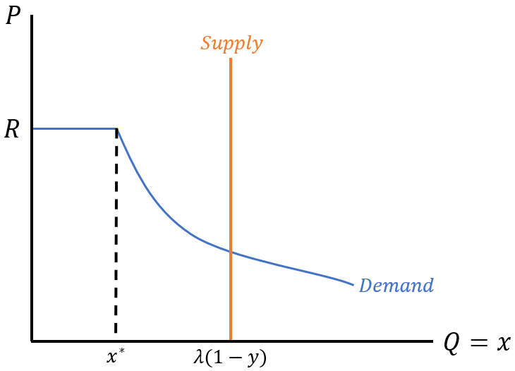

Figure – adapted from (Allen & Gale, 2007, p. 110)

Supply is fixed at $λ\left(1-y\right)$, i.e., $λx$, as this is the quantity of long assets held by early consumers. The demand line’s curved section shows cash-in-the-market pricing: if there are $x>x^{*}$ long assets available, there is an inverse quantity of short assets, i.e., initial overinvestment in illiquid assets by agents leads to a future shortage of liquidity. Allen & Gale (2007, p. 111) show the relationship between $P$ and liquidity preference with parameters: $R=1.2,λ_{L}=0.5,λ_{H}=0.67$; see Figure VII.

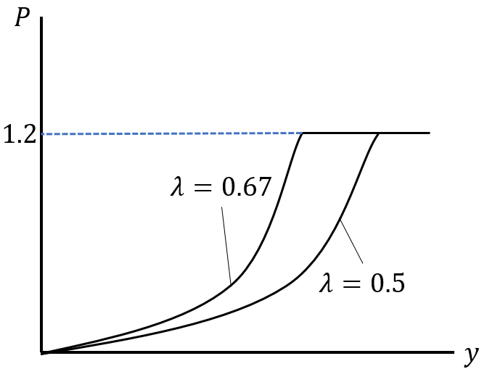

Figure – adapted from (Allen & Gale, 2007, p. 111)

This shows that greater initial liquidity preference incurs less cash-in-the-market pricing.

Adapting Figure VI to Minsky, we set $R=PV(Π_{LR}^{e})$ and modify the supply curve so that the long asset is produced rather than fixed in quantity. Agents are no longer aware of probability distributions, instead forming future liquidity preference expectations; see Figure VIII.

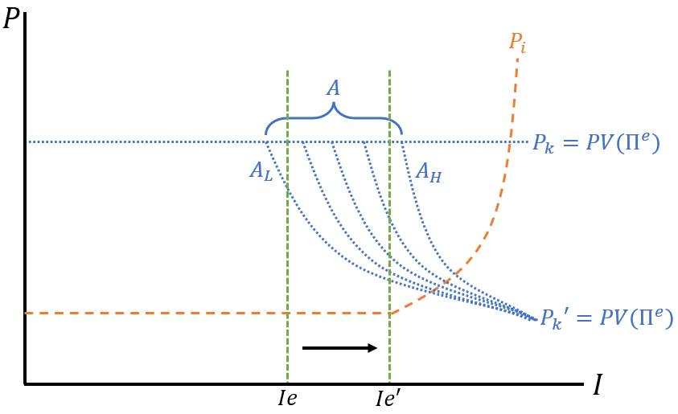

Figure – own illustration

$A$ denotes possible $P_{k}$ schedules following a sudden liquidity restriction. During an economic upswing, liquidity preference decreases because firms honour debt commitments, making assets like loans and fixed investments preferred to cash – Figure VII shows this shifts firms closer to $A_{L}$ because low liquidity preference will cause harsher cash-in-the-market pricing. Meanwhile, investment is expanding from $Ie→Ie'$. Combining these facts, we can conclude that the longer a boom presides, the more likely it is that capital assets experience cash-in-the-market pricing following a liquidity shock. A debt-deflation spiral follows if banks lose confidence in firms’ profit expectations.

In this paper I have explained the fundamental theory of the Financial Instability Hypothesis and demonstrated how it can be combined with Allen & Gale’s (2007) cash-in-the-market pricing model to incorporate liquidity preference uncertainty. This allows liquidity shocks to also be endogenised to the model, providing a fuller explanation of financial crises.

# Bibliography

Allen, F., & Gale, D. (2007). *Understanding Financial Crises.* Oxford: Oxford University Press.

De Antoni, E. (2006). Minsky on Financial Instability. In P. Arestis, & M. Sawyer, *A Handbook of Alternative Monetary Economics* (pp. 154-171). Cheltenham: Edward Elgar Publishing Limited.

Dow, S. C. (2006). Endogenous Money: Structuralist. In P. Arestis, & M. Sawyer, *A Handbook of Alternative Monetary Economics* (pp. 35-51). Cheltenham: Edward Elgar Publishing Limited.

Minsky, H. P. (1992). *The Financial Instability Hypothesis.* The Jerome Levy Economics Institute of Bard College.

Minsky, H. P. (2008). *Stabilizing an Unstable Economy.* New York: McGraw Hill.

Realfonzo, R. (2006). The Italian Circuitist Approach. In P. Arestis, & M. Sawyer, *A Handbook of Alternative Monetary Theories* (pp. 105-120). Cheltenham: Edward Elgar Publishing Limited.

Skott, P. (1996). Financial Innovation, Deregulation and Minsky Cycles. In G. Epstein, & H. Gintis, *Macroeconomic Policy after the Conservative Era* (p. Chapter 9). Cambridge: Cambridge University Press.